**Basic commands**

1) ls

-ls is list files and directories in bare format where we won’t be able to view details like file types, size, modified date and time, permission and links etc.

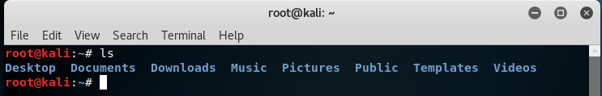

2) cd

-The cd command, which stands for "change directory", changes the shell's current working directory

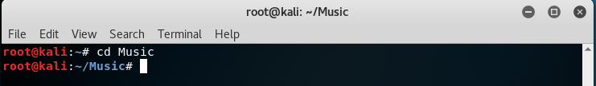

3) mv

-mv (short for move) is a Unix command that moves one or more files or directories from one place to another. If both file names are on the same file system, this results in a simple file rename; otherwise the file content is copied to the new location and the old file is removed.

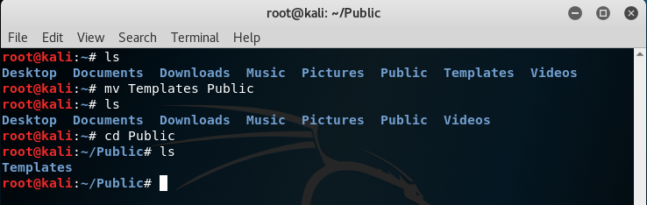

4) cat

-cat is a standard Unix utility that reads files sequentially, writing them to standard output. The name is derived from its function to concatenate files.

cat “file name” – display file

cat > “filename” – create file and add data

cat >> “filename” – add data to existing file

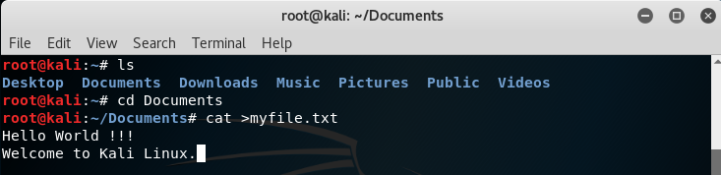

5) rm

-rm (short for remove) is a basic UNIX command used to remove objects such as files, directories, device nodes, symbolic links, and so on from the file system. To be more precise, rm removes references to objects from the file system.

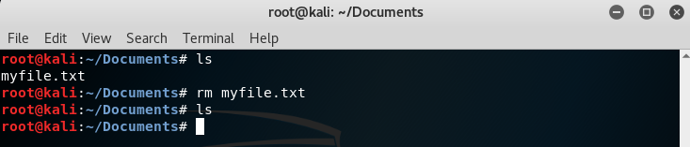

6) mkdir/rmdir

-The mkdir (make directory) command in the Unix, DOS, OS/2, and Microsoft Windows operating systems and in the PHP scripting language is used to make **a new directory**.

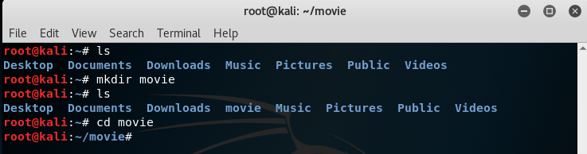

-The rmdir (make directory) command in the Unix, DOS, OS/2, and Microsoft Windows operating systems and in the PHP scripting language is used to remove a **directory**.

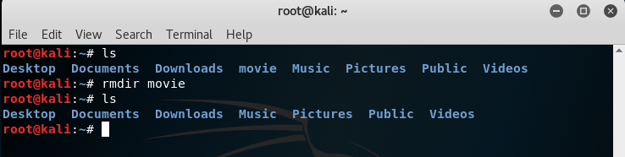

7) touch

-touch is a standard Unix command-line interface program which is used to update the access date and or modification date of a file or directory. In its default usage, it is the equivalent of creating or opening a file and saving it without any change to the file contents. Touch avoids opening, saving, and closing the file. Instead it simply updates the dates associated with the file or directory.

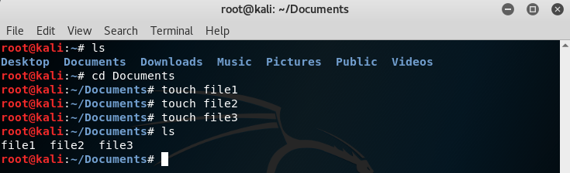

8) pwd

-The pwd command (print working directory) writes the full pathname of the current working directory to the standard output.

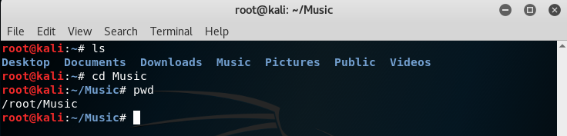

9) top

-top (table of processes) is a task manager program found in many Unix-like operating systems. It produces an ordered list of running processes selected by user-specified criteria, and updates it periodically.

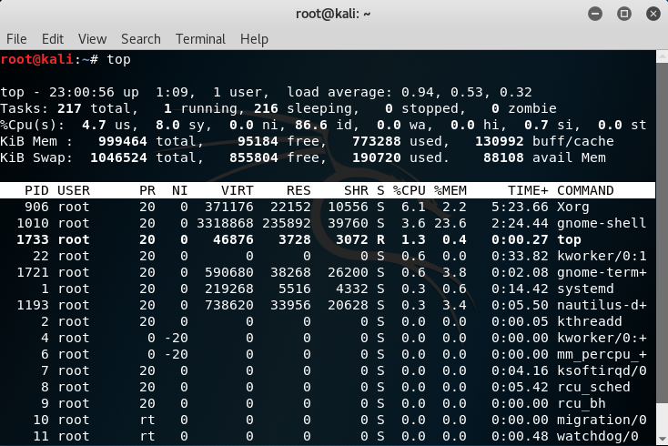

10) ps

-The ps program (short for "process status") displays the currently-running processes. A related Unix utility named top provides a real-time view of the running processes.

PID = Process ID number

TTY = Terminal associated with the process

CMD = Name of the process, including arguments.

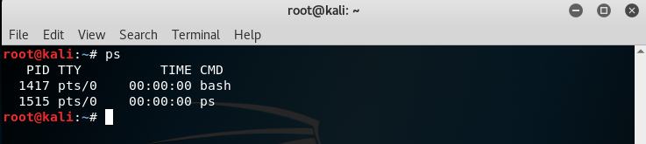

11) kill

-In computing, kill is a command that is used in several popular operating systems to send signals to running processes.

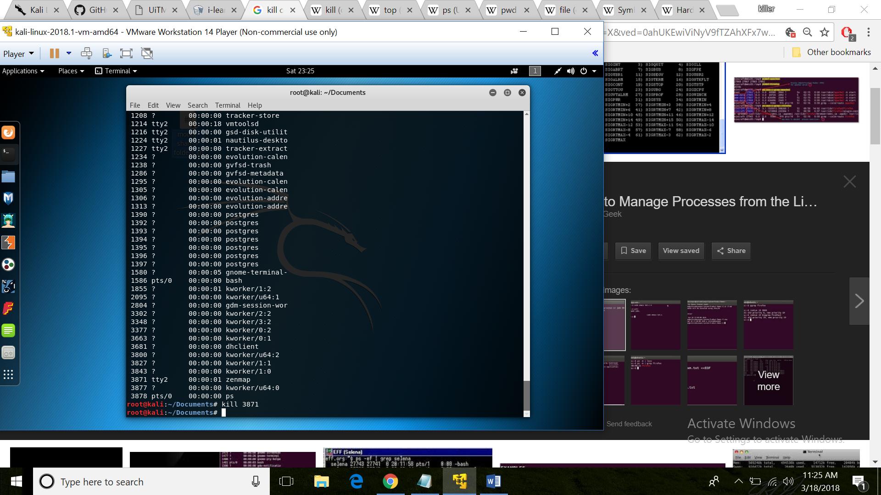

12) wc

-wc (short for word count) is a command in Unix-like operating systems. The program reads either standard input or a list of files and generates one or more of the following statistics: newline count, word count, and byte count. If a list of files is provided, both individual file and total statistics follow.

* wc -l <filename> prints the line count (note that if the last line does not have \n, it will not be counted)
* wc -c <filename> prints the byte count
* wc -m <filename> prints the character count
* wc -L <filename> prints the length of longest line (GNU extension)
* wc -w <filename> prints the word count

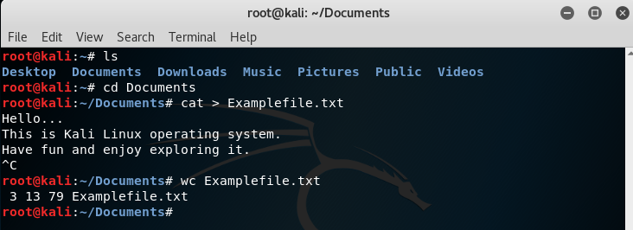

13) grep

-grep is a command-line utility for searching plain-text data sets for lines that match a regular expression. Its name comes from the ed command g/re/p (globally search a regular expression and print), which has the same effect: doing a global search with the regular expression and printing all matching lines

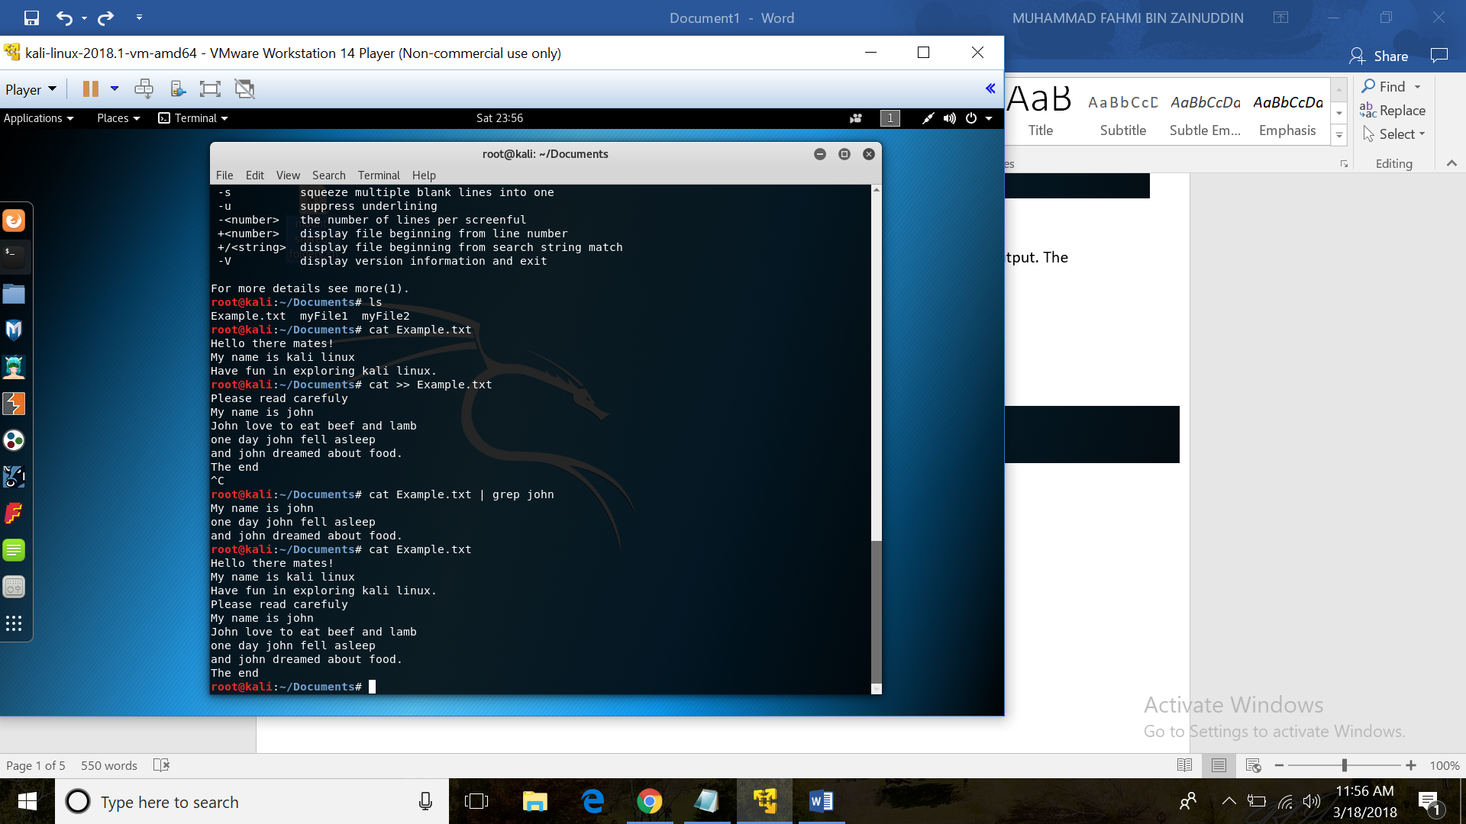

14) more/less

-more is a command to view (but not modify) the contents of a text file one screen at a time

**more [options] [file_name].**

* -num: This option specifies an integer which is the screen size (in lines).
* -d: more will prompt the user with the message "[Press space to continue, 'q' to quit.]" and will display "[Press 'h' for instructions.]" instead of ringing the bell when an illegal key is pressed.
* -l: more usually treats ^L (form feed) as a special character, and will pause after any line that contains a form feed. The -l option will prevent this behavior.
* -f: Causes more to count logical, rather than screen lines (i.e., long lines are not folded).
* -p: Do not scroll. Instead, clear the whole screen and then display the text.
* -c: Do not scroll. Instead, paint each screen from the top, clearing the remainder of each line as it is displayed.
* -s: Squeeze multiple blank lines into one.
* -u: Backspaces and carriage returns to be treated as printable characters;
* +/: This option specifies a string that will be searched for before each file is displayed. (Ex.: more +/Preamble gpl.txt)
* +num: Start at line number num.

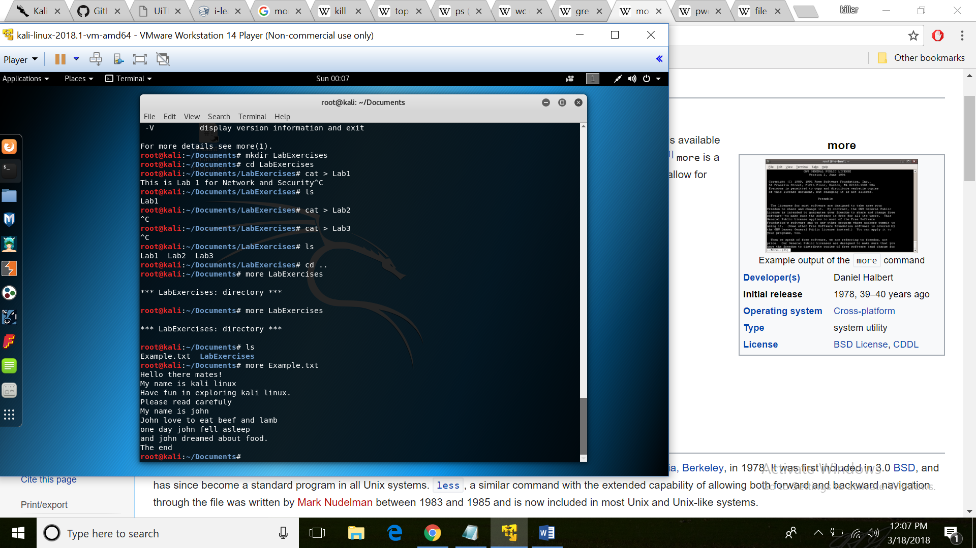

-less is a terminal pager program on Unix, Windows, and Unix-like systems used to view (but not change) the contents of a text file one screen at a time. It is similar to more, but has the extended capability of allowing both forward and backward navigation through the file.

**less [options] [file_name].**

* -g: Highlights just the current match of any searched string.
* -I: Case-insensitive searches.
* -M: Shows more detailed prompt, including file position.
* -N: Shows line numbers (useful for source code viewing).
* -S: Disables line wrap ("chop long lines"). Long lines can be seen by side scrolling.
* -X: Leave file contents on screen when less exits.
* -?: Shows help.
* +F: Follow mode for log.

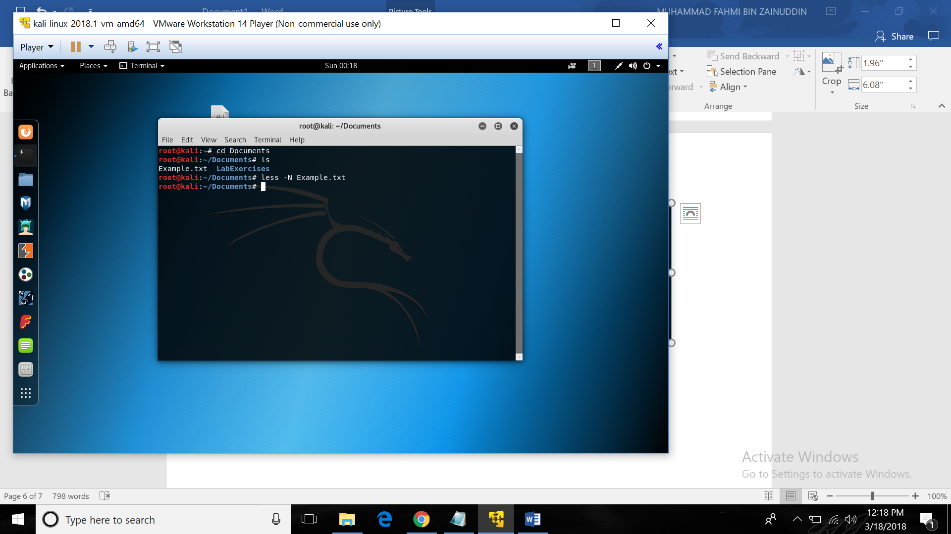

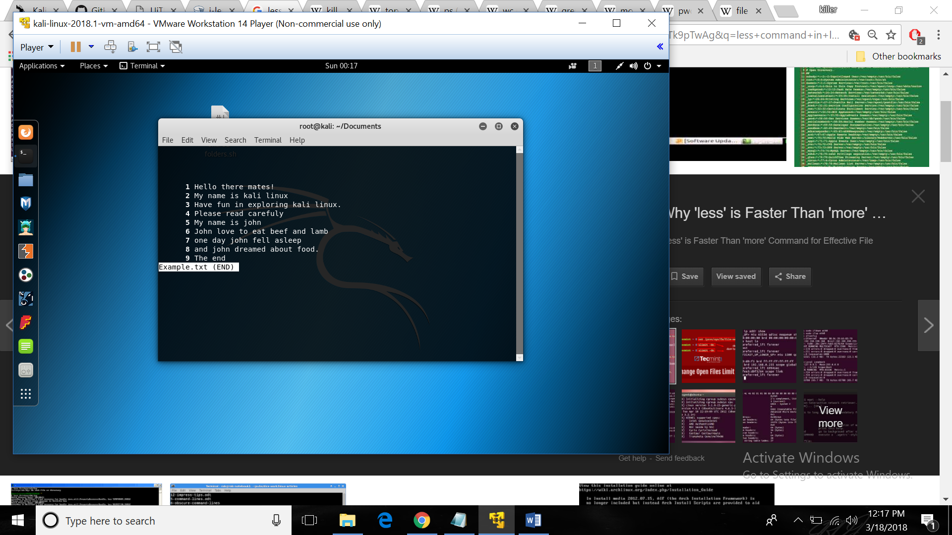

15) ping

-Ping is a computer network administration software utility used to test the reachability of a host on an Internet Protocol (IP) network. It measures the round-trip time for messages sent from the originating host to a destination computer that are echoed back to the source.

* H, !N or !P – host, network or protocol unreachable
* S – source route failed
* F – fragmentation needed
* U or !W – destination network/host unknown
* I – source host is isolated
* A – communication with destination network administratively prohibited
* Z – communication with destination host administratively prohibited
* Q – for this ToS the destination network is unreachable
* T – for this ToS the destination host is unreachable
* X – communication administratively prohibited
* V – host precedence violation
* C – precedence cutoff in effecter that are echoed back to the source.

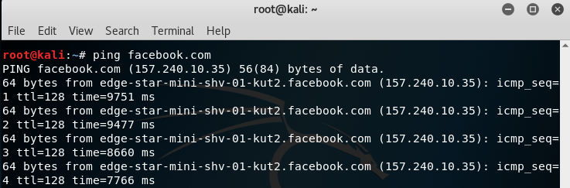 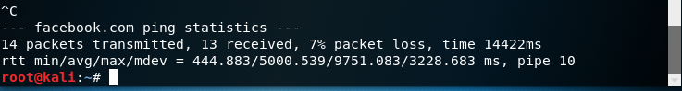

16) uname

-uname (short for unix name) is a computer program in Unix and Unix-like computer operating systems that prints the name, version and other details about the current machine and the operating system running on it

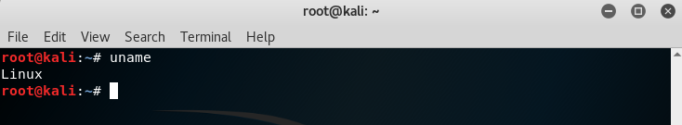

17) uptime

-Display the time since the last boot 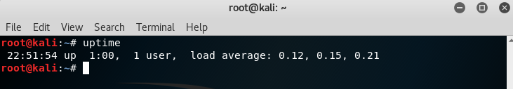

18) netstat

-netstat (network statistics) is a command-line network utility tool that displays network connections for the Transmission Control Protocol (both incoming and outgoing), routing tables, and a number of network interface (network interface controller or software-defined network interface) and network protocol statistics.

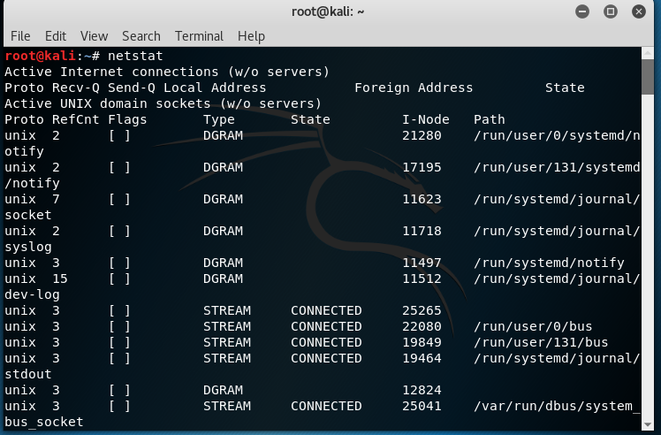

19) chmod

-chmod is the command and system call which may change the access permissions to file system objects (files and directories).

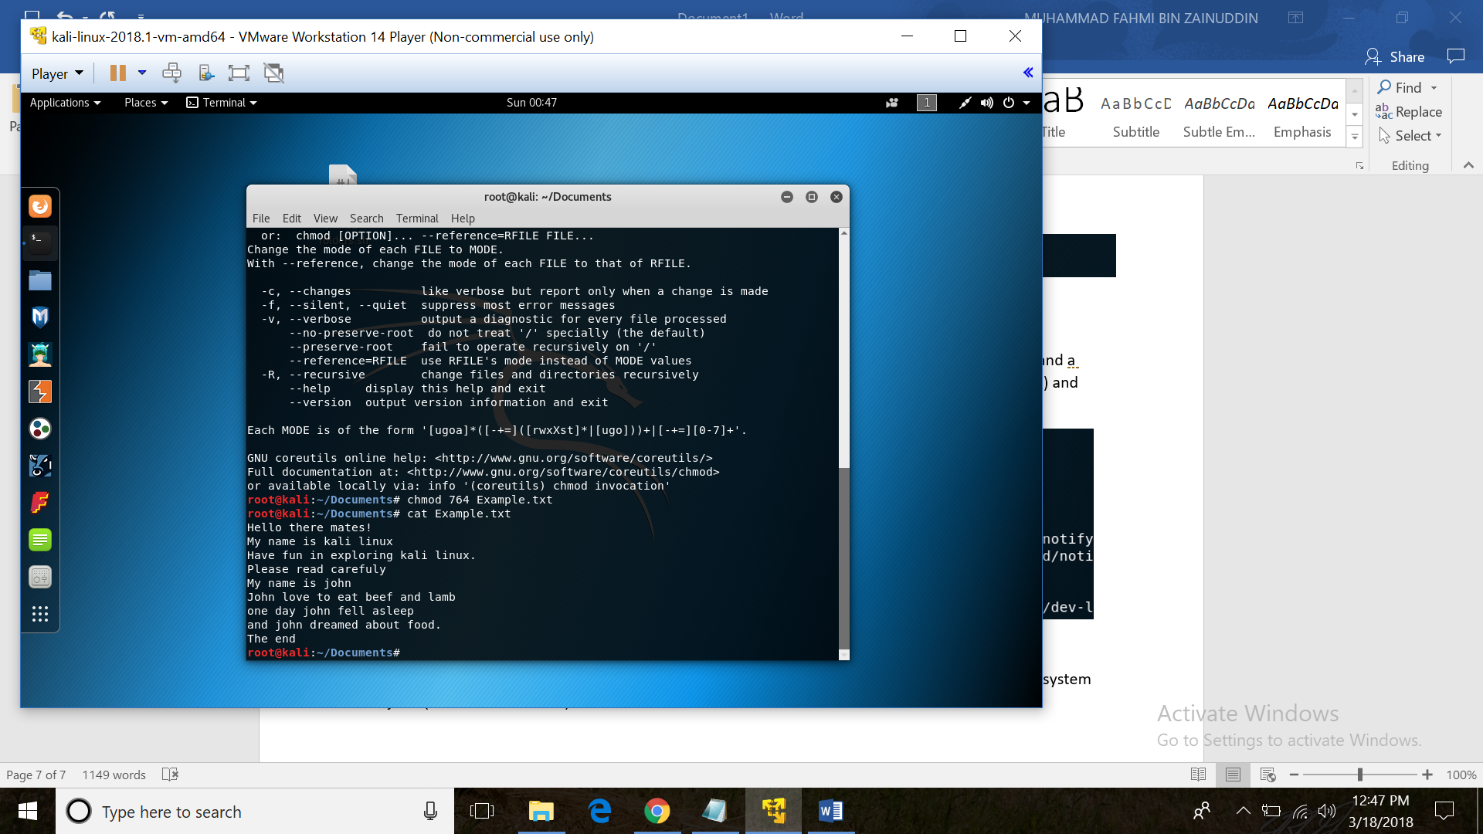

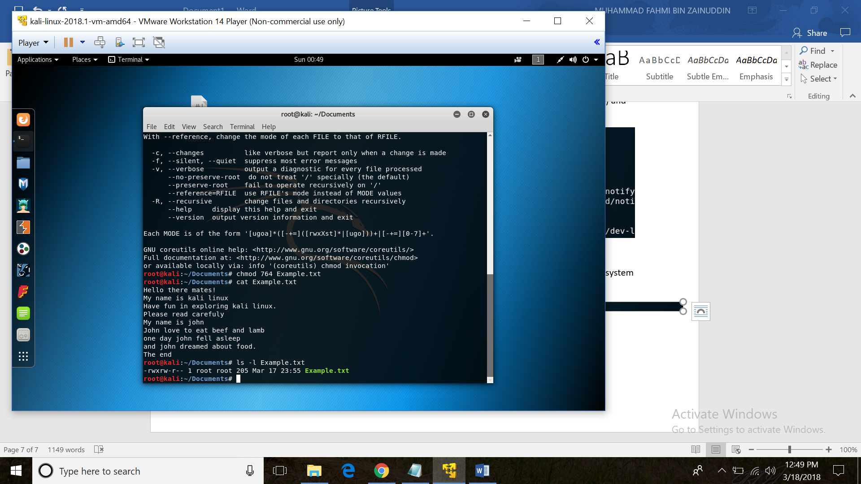

20) chown

-The command chown, an abbreviation of change owner, is used on Unix-like systems to change the owner of file system files, directories. Unprivileged (regular) users who wish to change the group membership of a file that they own.

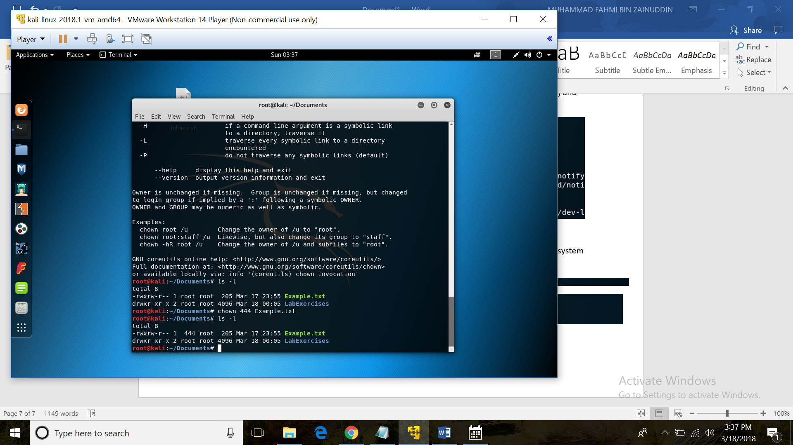

21) file

-The command file is to determine type of file for example single file, multiple file, viewing mime type and compressed file.

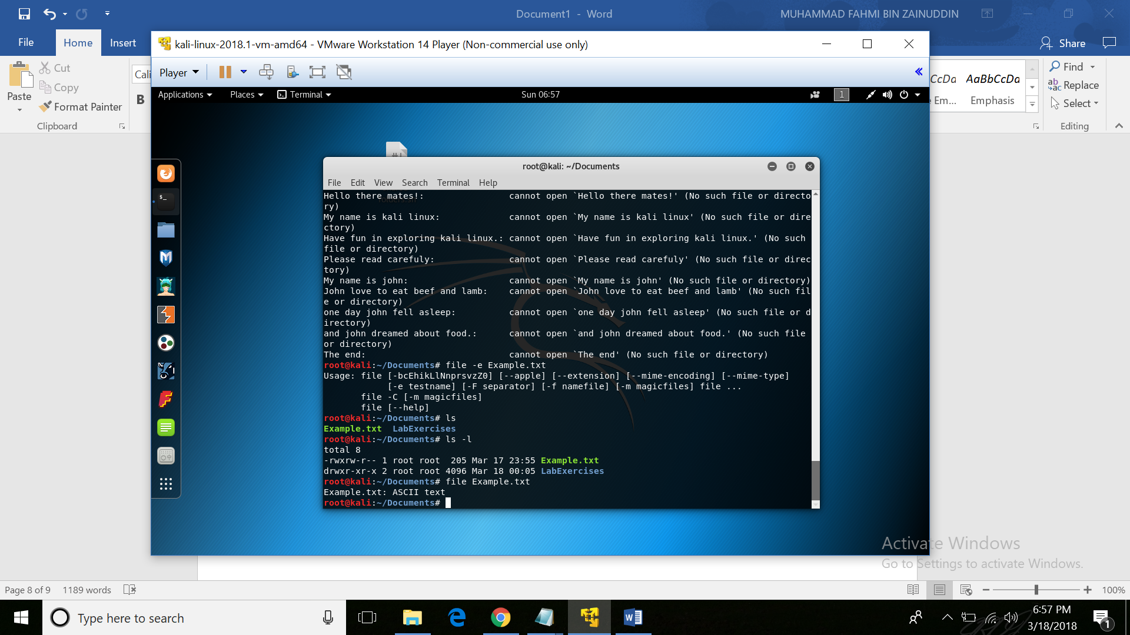

22) ln

-The ln command is a standard Unix command utility used to create a hard link or a symbolic link (symlink) to an existing file.

* -f Force existing destination pathnames to be removed to allow the link.
* -L For each source_file operand that names a file that is a symbolic link, create a hard link to the file referenced by the symbolic link.
* -P For each source_file operand that names a file that is a symbolic link, create a (hard) link to the symbolic link itself.
* -s Create symbolic links instead of hard links. If the -s option is specified, the -L and -P options are silently ignored.

